**Hands on – DDL and DML Statements**

**Hands on Name: Travel Management System**

**Description:**

ABC Corporation tells you to build an automated travel management system so that they can track the agent details, the customer details and the travels by the customer. Help the organization management by solving the below queries given by the management.

Refer to the schema diagram below for your work:

**Schema Name: dbTravel**

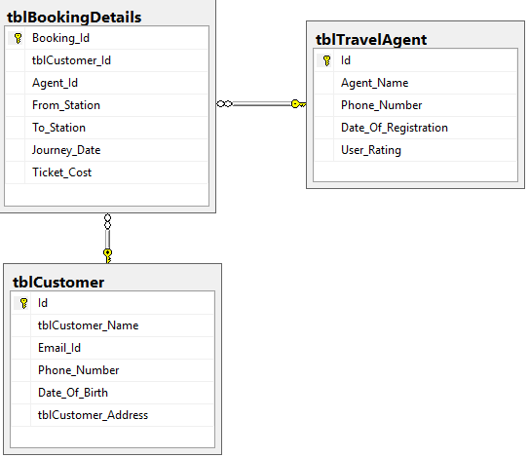

**Now based on the above schema and sample records solve the below queries:**

1. Display the agent_id, agent_name, phone_number and rating from tblTravelAgenttable.

Note: Display only last 4 numbers of agent id using alias as Agent_ID

Display rating as follows:

If rating is >=0 to <5 display as “Average”

If rating >=5 and <8 display as “Good”

Rating >=8 display “Excellent”

Use alias as Rating.

**[Test Case: Be careful of right side spaces in ID]**

**[Note: Order of columns for output is agent_id, agent_name, phone_number and Rating].**

2. Display the customer_id, customer_name, email, phone and dob of all customers who are born in the month of MAY in ascending order by customer name and then by their id.

Note: If phone number is missing display “Phone not found”. Use alias as Phone_Number.

**[Note: The order of columns for output should be same as given in question].**

Q3. Display the customer name, address and age of customers who are >=20 years old. [Display age as Age where age is calculated by deducting dob from current date]

Display the customer name in upper case with alias Name.

Formula for Age: round(datediff(Curdate(),Date_Of_Birth)/365,0)

**[Note: The order of columns for output should be same as given in question].**

Q4. Display all the agents and matching details of travel bookings. If the agent has no travel bookings display the bookings side as null. Display the records in ascending order by agent name.

Q5. Display the customer name and total number of tickets booked by each customer [Alias Total_Bookings] in descending order by count of tickets. [Note: If a customer has not booked any ticket show the ticket count as 0].

**[Note: The order of columns for output should be same as given in question].**

Q6. Display the customer id and name of the customer who have booked the highest number of tickets.

**[Note: The order of columns for output should be same as given in question].**